# Lab 4 - Data Exploration and charts

1. Notice that we have some blanks in our data. We want to clean up our data and get rid of the blanks
2. Drag the **Country** field from the **Geography** table to the Fields pane and drop it in **Filters on all pages**
3. Change filter type to **Advanced filtering** and select **is not blank,** click on **Apply Filter NOTE:** Additional filter options are available: is blank, is empty, is not empty

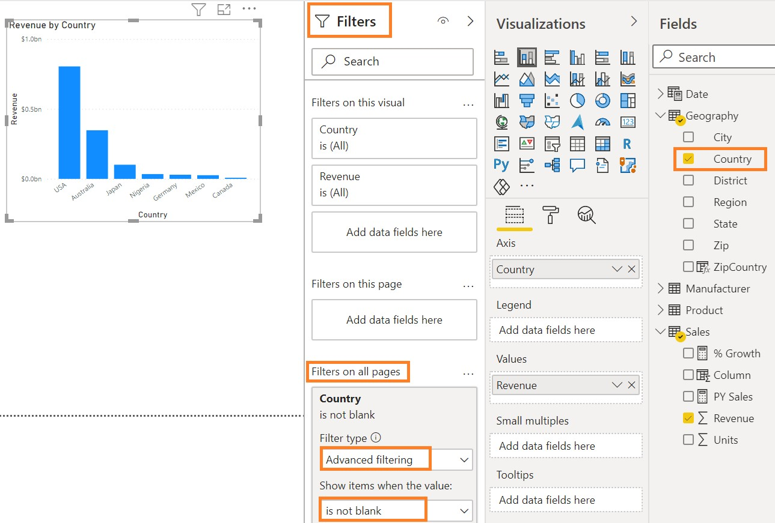

1. From the **Fields** section, expand the **Manufacturer** table, and then drag the **Manufacturer** column to the **Legend** section under Visualizations.
2. While you have your chart selected, click the **Clustered column chart** from the **Visualizations**

section, and then click the **Stacked column chart** visual.

1. **Resize** the visual as needed.

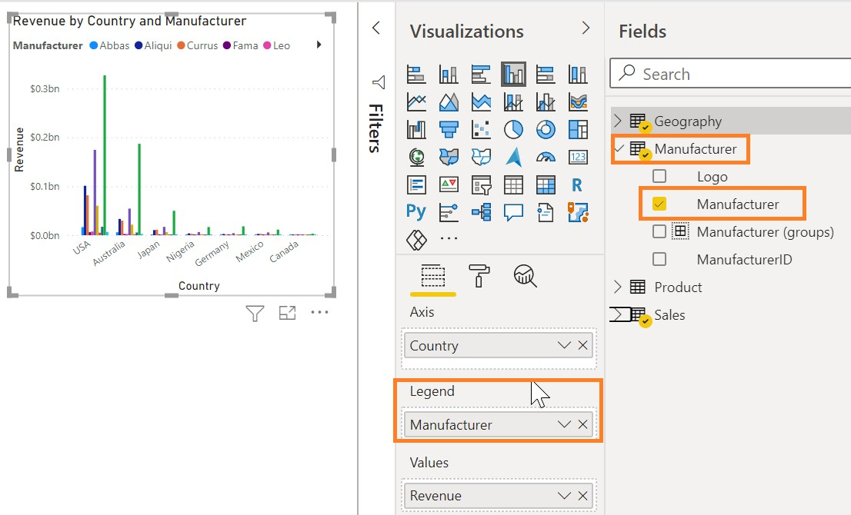

Now we can see the top manufacturers by country.

Now let’s try different visuals to see which chart represents the data the best.

1. Begin with the **Stacked column chart** selected.

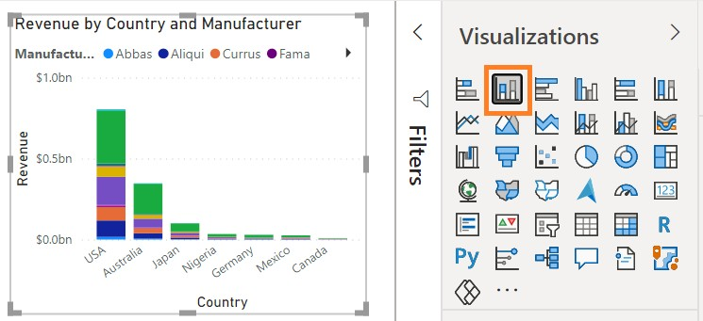

1. In the **Filters** pane, expand **Manufacturer**.
2. From the **Filter Type** dropdown menu, click **Top N**.
3. Enter **5** in the text box next to **Top**.
4. From the **Sales** table, drag and drop the **Revenue** field into the **By value** section.
5. Click on **Apply filter**.

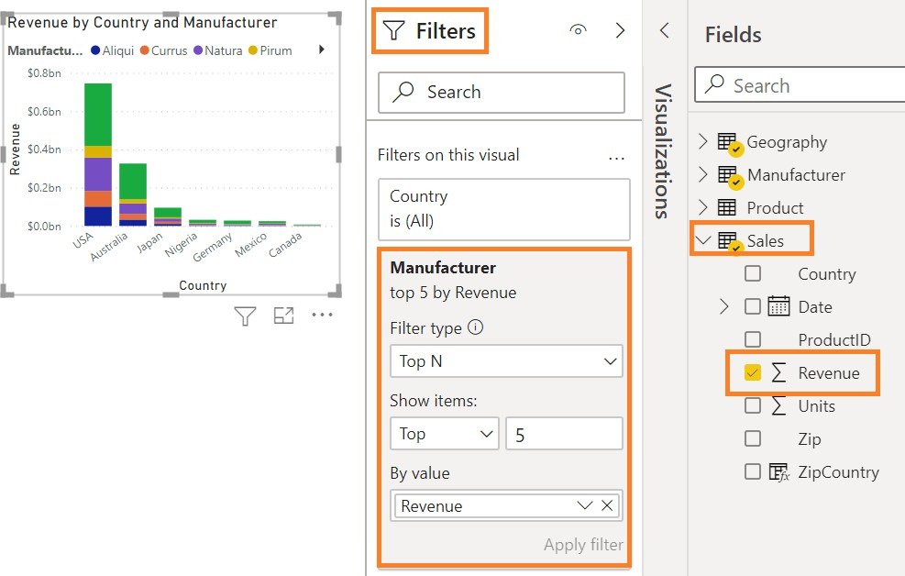

Notice that the visual is filtered to display the top five manufacturers by Revenue. We see that the manufacturer VanArsdel has a higher percentage of sales in Australia compared to other countries or regions.

We can now add total labels to the stacked visuals

1. Click on the **paint roller** icon
2. Click Total labels to **On**

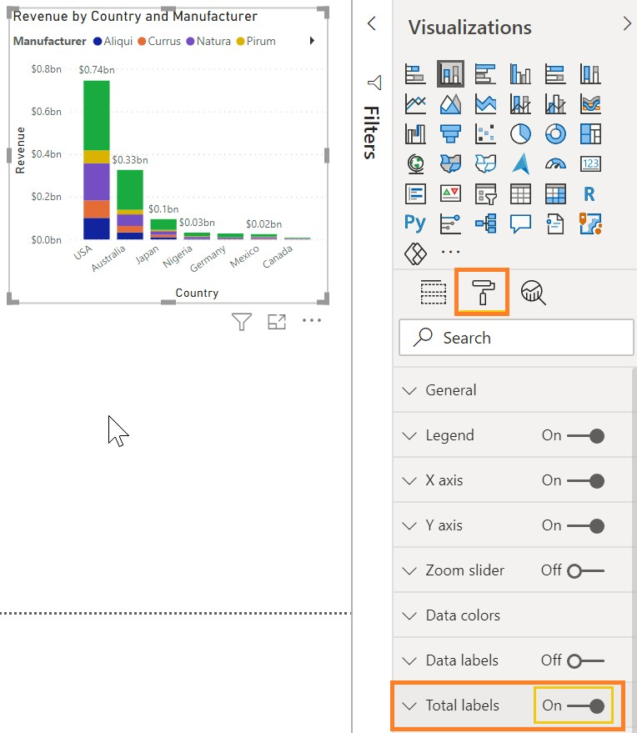

Let’s remove the total labels

1. Click Total labels to the **Off** position

We are interested in the top five competitors by revenue. Let’s group them so we don’t have to add a

filter to every visual. Before we do that, we’ll remove the **Top 5** visual level filter.

1. Begin with **Clustered column chart** selected.
2. Hover over and click the **Clear filter** icon (erase) next to **Manufacturer** field in the **Filters** Pane.

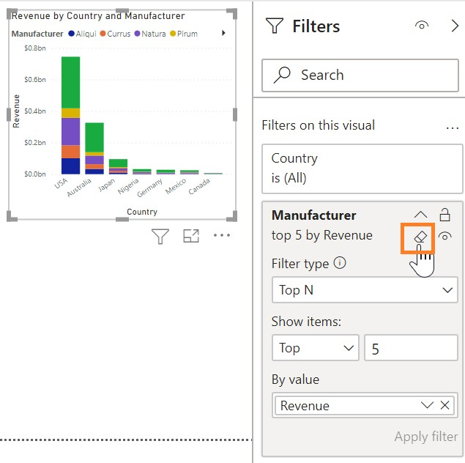

1. From the **Fields** section, right-click on the **Manufacturer** field name from **Manufacturer** table.

**Note**: do not check the checkbox.

1. Click **New Group.**
2. In the **Ungrouped values** section, using **Ctrl** key, click **Aliqui, Currus, Natura**, and **Pirum**.
3. Click the **Group** button. Notice a new group is added in the **Groups and members** section.
4. Double-click the newly created group and rename it **Top Competitors**.
5. Click **VanArsdel** from the **Ungrouped values** section and click the **Group** button to create the

**VanArsdel** group.

1. Click the checkbox **Include Other group**. This will create another **Other** group that includes all the other manufacturers.
2. Click **OK** to close the **Groups** dialog.

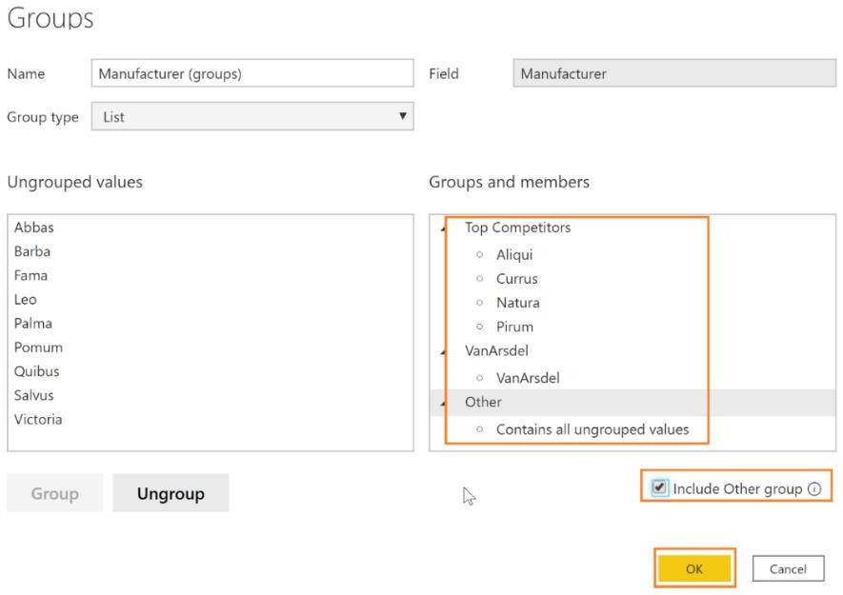

1. With the **Stacked column chart** selected, click on the **X** next to **Manufacturer** in the **Legend**

section. This will remove the Manufacturer.

1. From the **Fields** section, drag the newly created **Manufacturer (groups)** to the **Legend** section. Now we can see that VanArsdel has nearly 50% share in Australia.

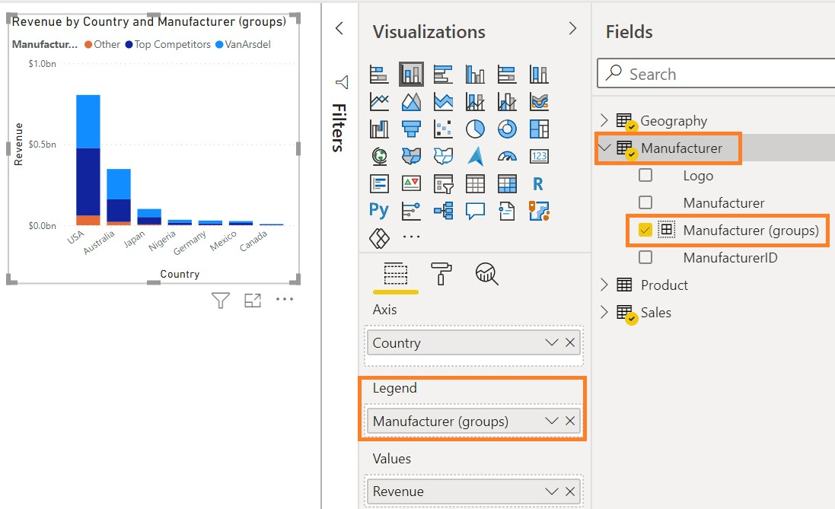

1. Hover over one of the columns and right-click.
2. Click **Show as a table**. You will now be in **Focus** mode with the chart displayed on top and the data displayed below. Notice that VanArsdel has a large percent of the Australian market.
3. Use the icon in the top right corner to switch to the vertical layout. In this layout, you view the chart on the left panel and the data on the right panel.
4. Click **Back to Report** to go back to the **Report** canvas.

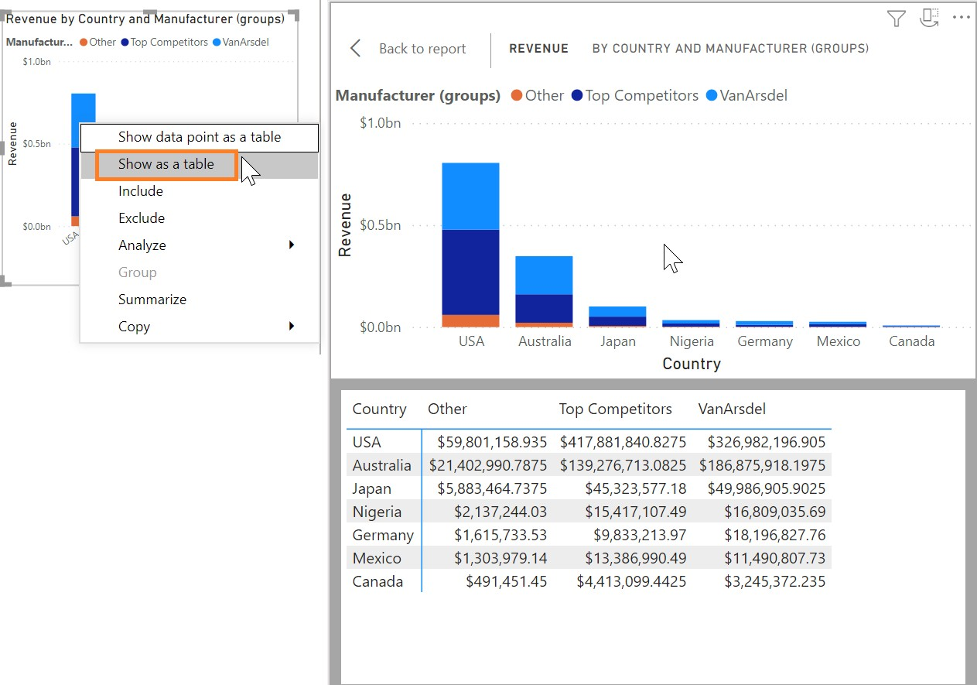

**Note**: You can use similar steps to **Show data point as a table** to see records for a specific data point.

Now let’s create a Revenue by Manufacturer visual.

1. Click on the white space in the canvas. From the **Fields** section, click the checkbox next to the

**Revenue** field in the **Sales** table.

1. From the **Fields** section, click the checkbox next to the **Manufacturer** field in the **Manufacturer**

table.

1. From the **Visualizations** section, click the **Treemap** visual.

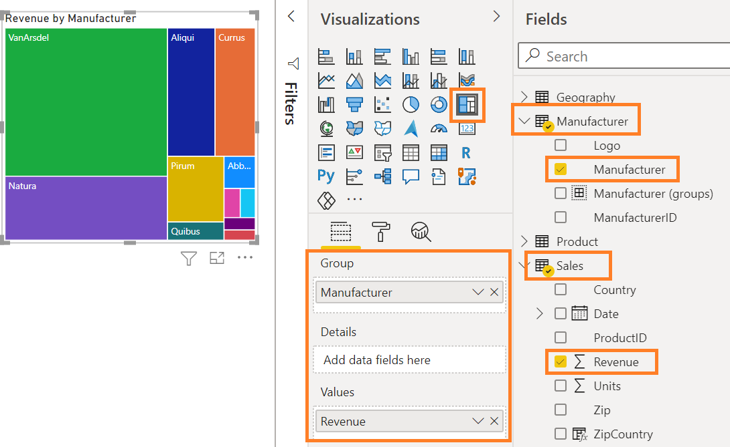

We now have Revenue by Manufacturer. Now let’s turn our attention to the interaction between the Stacked column chart and the Treemap visuals.

1. In the **Treemap**, click **VanArsdel** and notice that the Stacked column chart is filtered. This confirms that VanArsdel has a large percentage of the Australian market.

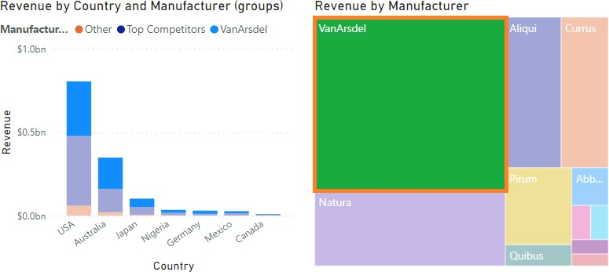

S

1. To remove the filter, click **VanArsdel** again.

This interaction between visuals is called cross-filtering.

Previously, we added a Top 5 Visual level filter. Now let’s add a filter to the Page level, so we are working with the Top Competitors and VanArsdel and filter out the other manufacturers.

Page-level filters apply to all visuals on the page. Visual-level filters apply only to a visual. Ensure the Filters pane is expanded/open.

1. From the **Fields** section, drag **Manufacturer (groups)** from the **Manufacturer** table to the **Filters on this page** box in the **Filters Pane.**

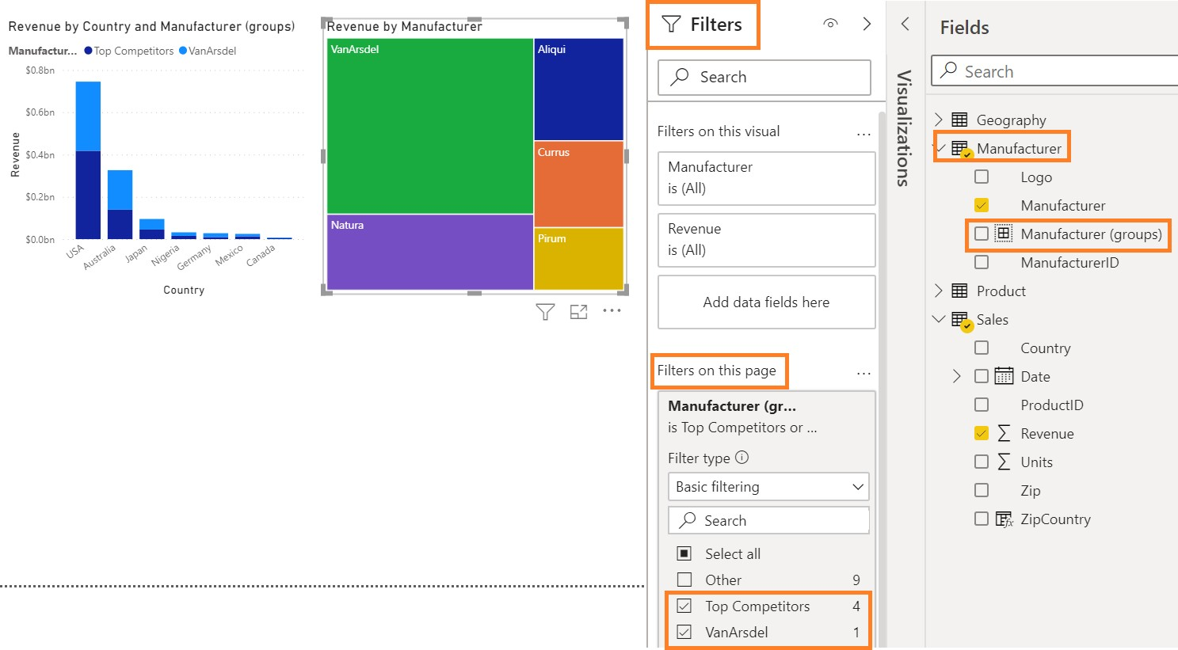

1. Click **Top Competitors** and **VanArsdel**.

Now, let’s add a visual that provides sales information over time

1. Begin by clicking on the white space in the canvas.
2. Click the checkbox next to the **Date** field in the **Sales** table. Notice that a Date Hierarchy is created.
3. Click the checkbox next to the **Revenue** in the **Sales** table field. Notice that a Clustered column chart is created. Also notice in the **Axis** section, a date hierarchy is created. There are arrows on the top bar of the chart which are used to navigate through the hierarchy.

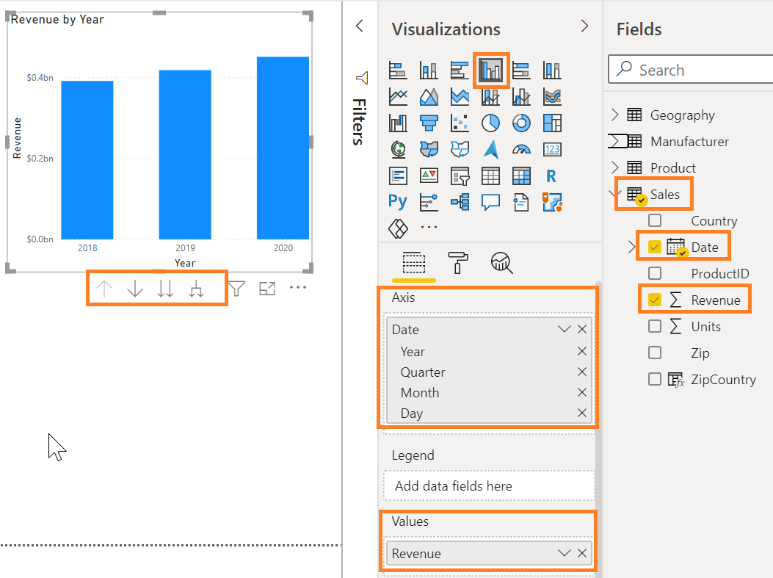

1. Click on the **Australia** column in the **Revenue by Country** visual.
2. With the **Revenue by Country** visual selected, from the ribbon click on **Format**, and then click **Edit Interactions**. Notice on the top right of the other two visuals new icons with the highlight icon selected.
3. Click the **filter icon** for both visuals.

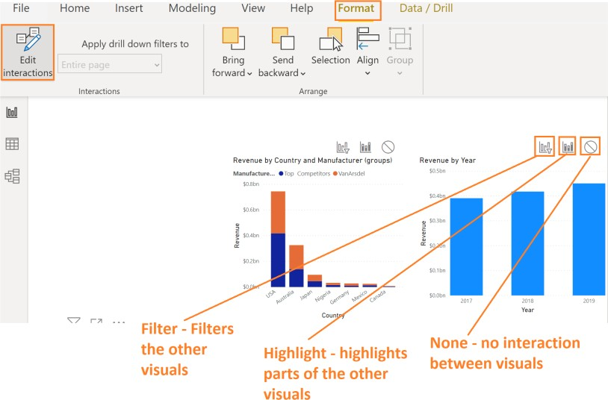

Notice now in both Revenue by Year and Revenue by Manufacturer, data is filtered for Australia

1. Now click the **Revenue by Year** visual.
2. Next, click the **filter** icon on the other two visuals.

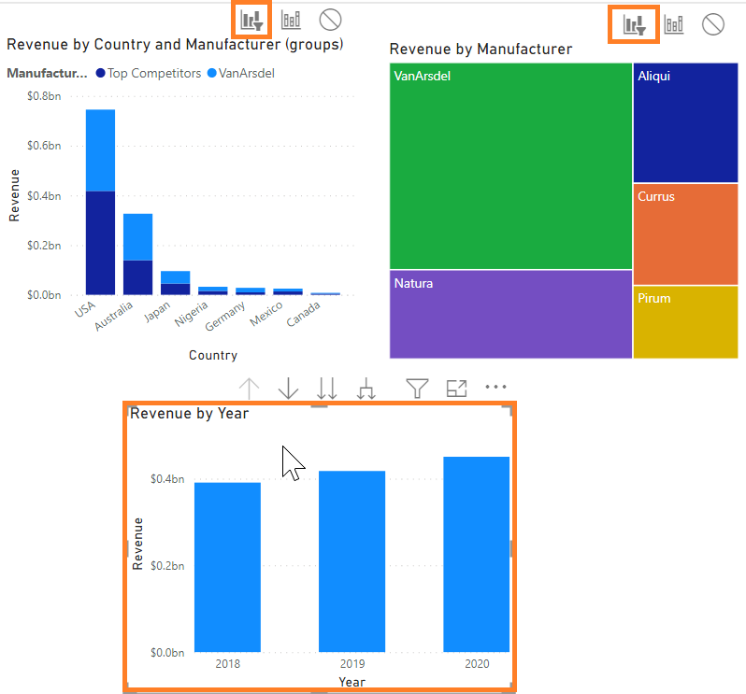

1. Similarly, click on the **Revenue by Manufacturer** visual and click the **filter icon** on the other **two visuals**. Once you are done, all the visuals should be in filter mode.
2. With the **Revenue by Manufacturer** visual selected, from the ribbon click **Format** then **Edit Interactions** to remove the icons.
3. Click on VanArsdel in the Revenue by Manufaturer visual

Note: If your screen doesn’t look like the one below please edit your interactions.

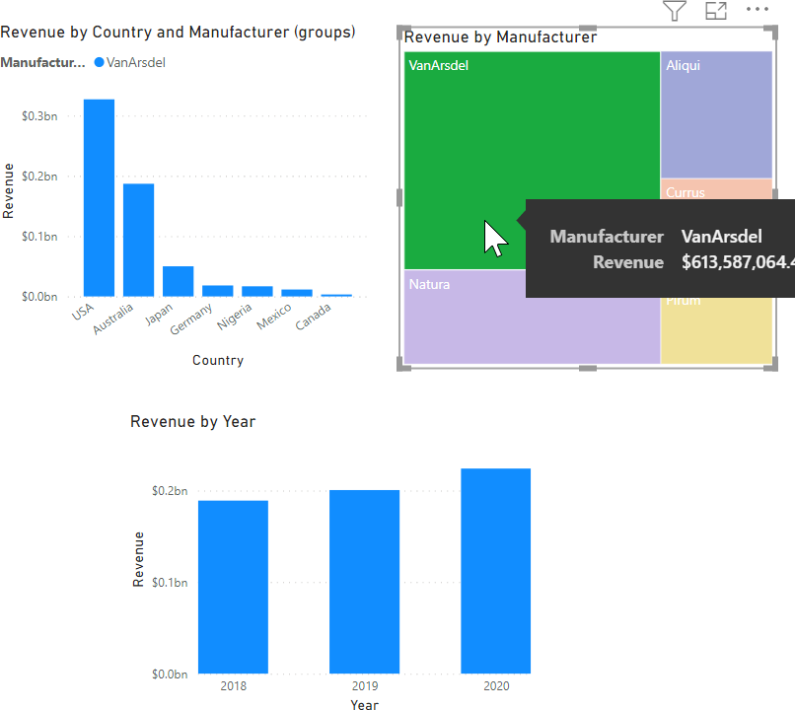

We have already noticed that VanArsdel has a large share of the market in Australia. Let’s see how VanArsdel has done over time in Australia.

1. Click on the **Revenue by Country and Manufacturer (groups)** chart and remove **Manufacturer (groups)** from the legend.
2. Click on **VanArsdel** in the **Revenue by Manufacturer** visual.
3. **Ctrl+Click** the **Australia column** in the **Revenue by Country** visual.

Now we have filtered the charts by both VanArsdel and Australia. Looking at the results, we can see a spike in 2020 sales for VanArsdel in Australia. This spike in sales is intriguing, so let’s investigate further.

1. Click the down arrow on the top of the **Revenue by Year** visual. This enables drill-down capability.

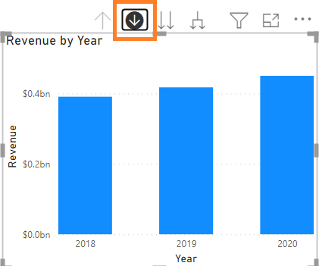

1. Click the **2020** column in the **Revenue by Year** visual.

Notice that you have drilled down to the quarter level of 2020. There was a big spike in the fourth quarter. Let’s dig further.

1. Click on the double arrow icon on the top of the **Revenue by Year** visual. This drills down to the next level of the hierarchy, which is the month.

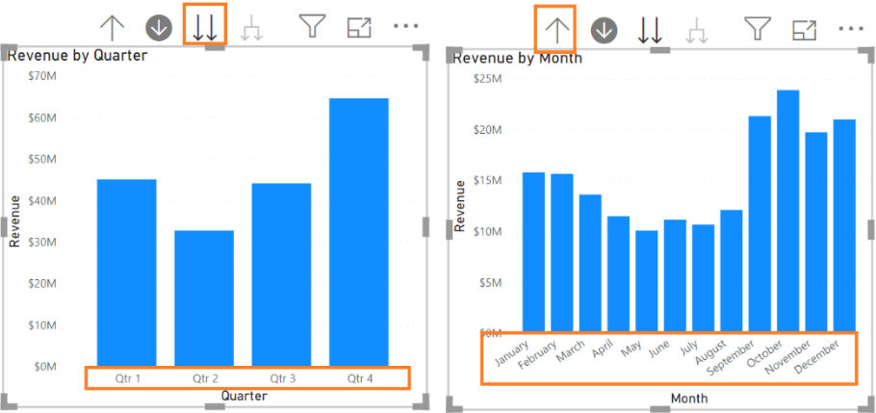

1. Click on the up-arrow icon on the top of the **Revenue by Year** visual to drill up to the **Quarter** level.
2. Click on the drill up icon again to go up to the **Year** level
3. Click on the split arrow icon on the top right of the **Revenue by Year** visual. This expands down to the next level of the hierarchy, which is quarters for all the years.

Notice that the fourth-quarter sales have always been high, but in 2020 there was a larger sales spike in the fourth quarter than usual.

1. Now let’s expand down to the month level. Click on the split arrow icon on the top right of the **Revenue by Year** visual. This expands down to the next level of the hierarchy, which is months for all the years.

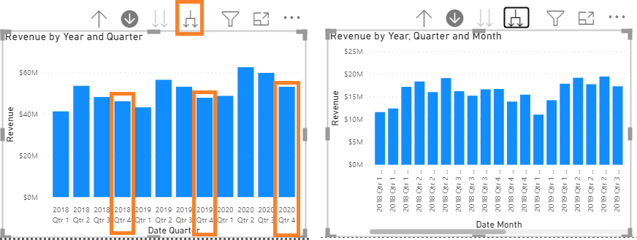

There is a lot of information in the visual and we must scroll left and right to compare.

## Power BI Desktop – Data Exploration Continued

Now that we’ve explored the data, let’s add a slicer so we can filter by the manufacturers.

1. Click on the white space in the canvas. From the **Fields** section, click the checkbox next to the

**Manufacturer** field in the **Manufacturer** table**.**

1. From the **Visualizations** section, click on the **Slicer** visual.
2. Here you will see a list of Manufacturers. Click **VanArsdel** and notice that all the visuals are filtered based on your selection.
3. Hover over the top right corner of the visual and click on the down arrow. Notice you have the option to change the slicer from a list to a dropdown.
4. Click **Dropdown**.
5. Click **VanArsdel** from the dropdown.

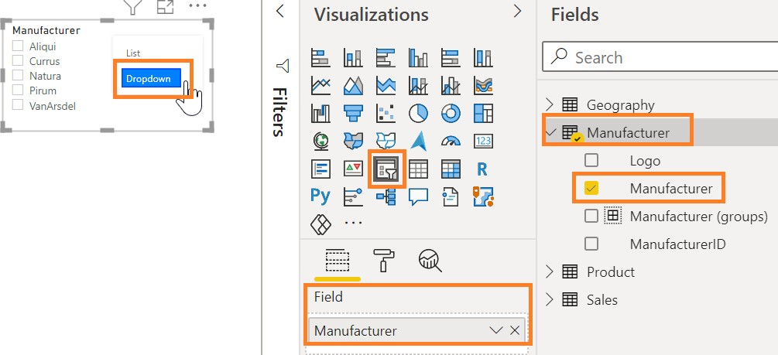

1. Confirm **Top Competitors** and **VanArsdel** are selected in the **Manufacturer (groups)** filter in the

**Filters** pane.

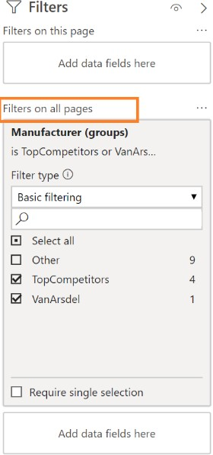

1. In the drop down filter select **VanArsdel**

Note that there is a box for **Filters on all pages** in the **Filters** pane. If you have duplicate pages, this is how you sync a filter for the whole file.

Now let’s use the **Manufacturer** slicer to analyze one manufacturer at a time.

1. Begin by clicking on the **Revenue by Manufacturer Treemap** visual.
2. From the **Visualizations** section, click on the **Card** visual.

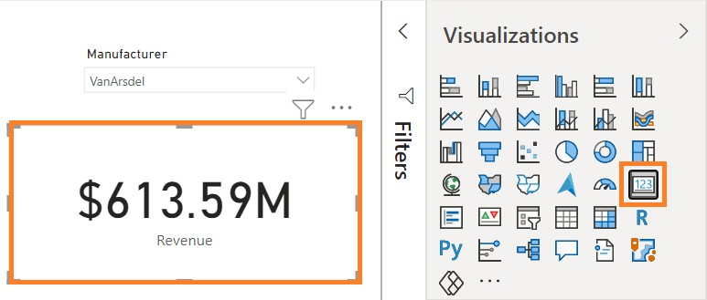

The card visual gives us the Revenue as we filter and cross-filter the visuals.

Notice that all key dimensions are in their table with related attributes, except the date. For example,

**Product** attributes are in the **Product** table. Now let’s create a **Date** table.

1. Navigate to the **Data** view by clicking on the **Data** icon in the left panel.
2. From the ribbon, click on **Table Tools**, then click on **New Table**.

Notice that a new table is created in the **Fields** section on the right and that the formula bar opens.

1. Enter **Date =CALENDAR (DATE(2012,1,1), DATE(2020,12,31))** in the formula bar and click on the checkmark. A **Date** table with a **Date** column is created.

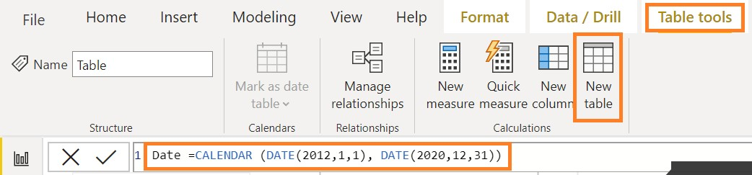

We are using two DAX functions: the **CALENDAR** function, which takes the start and end data, and the

**DATE** function, which takes the **year**, **month**, and **date** Fields.

For this lab, we will create Dates from 2012 to 2020, since we have data for those years. We can also add more Fields, like **Year**, **Month**, **Week**, etc., to this table by using DAX functions.

Notice that the **Date** field is of the type **Date/Time**. Let’s change it to the **Date** data type.

1. Click on the **Date** field in the **Date** table.
2. From the ribbon, click **Column Tools**, click **Data type**, and then click **Date**.

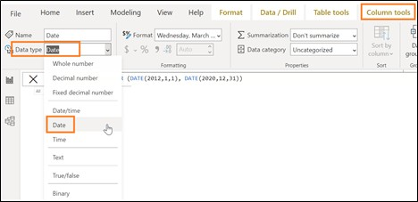

Next, we need to create a relationship between the newly created **Date** table and the **Sales** table.

1. From the ribbon, click **Column Tools,** and then click **Manage Relationships**.
2. A **Manage Relationships** dialog box opens. Click the **New** button.
3. A **Create Relationship** dialog box opens. Click **Date** from the top dropdown menu.
4. Click **Sales** from the second dropdown menu.
5. Highlight the **Date** Field in both tables.
6. Click **OK** to close the **Create relationship** dialog box.

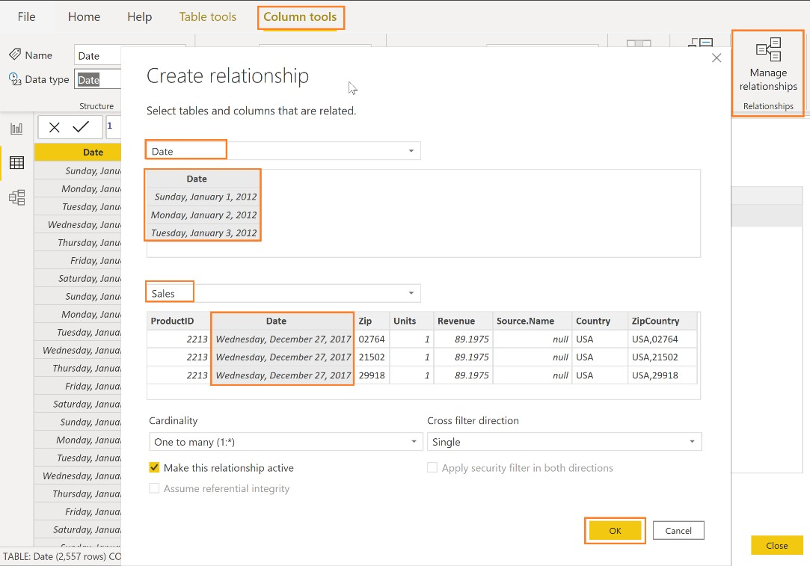

1. Click **Close** to close the **Manage relationships** dialog box.
2. Navigate to the Report view by clicking on the **Report** icon in the left panel. Notice that the Revenue by Date chart looks different. Let’s fix it.
3. Click the **Revenue by Date** visual.
4. From the **Axis,** click on the “**X**” to remove the **Date** field.

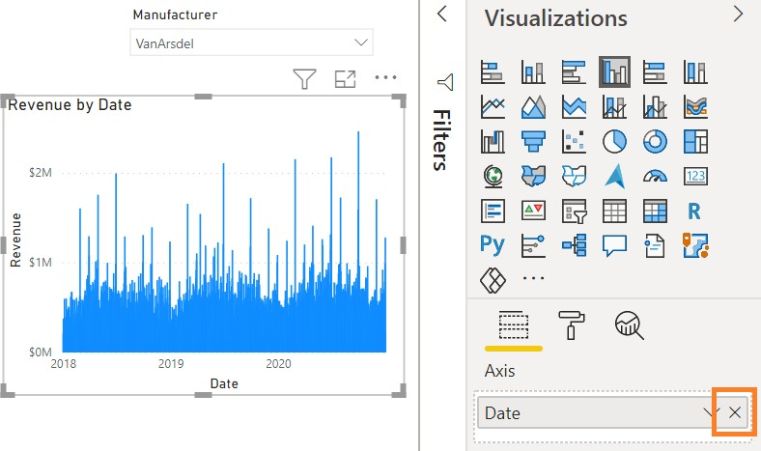

1. From the **Fields** section, expand the **Date** table.
2. Now drag the **Date** field to the **Axis** section.

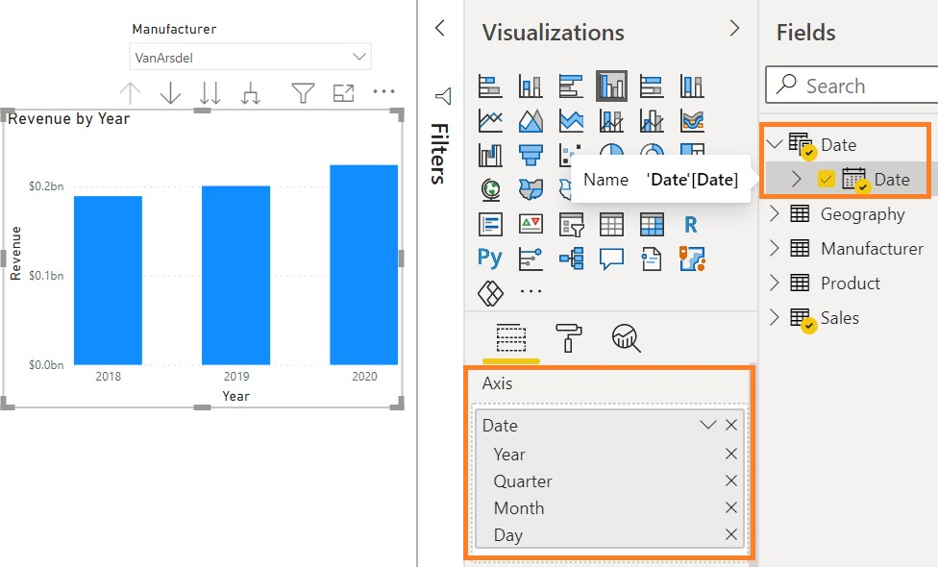

Notice that the new **Date** field behavior is like it was previously.

Since there are now two Date Fields, it may be confusing to know which one to use. To accommodate this, let’s hide the **Date** field in the **Sales** table.

1. From the **Fields** section, click on the **Hide** icon next to the **Date** field in the **Sales** table.

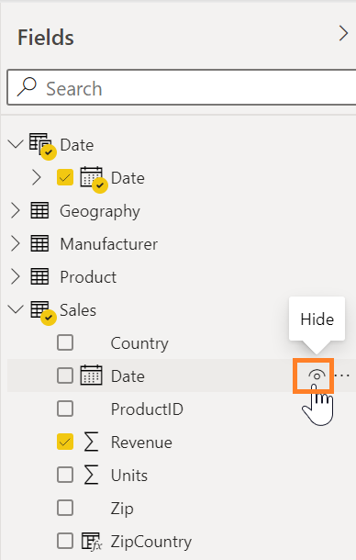

1. In the same way, hide **Country**, **ProductID**, **Zip**, and **ZipCountry** in the **Sales** table as well.
2. Now hide **ZipCountry** from the **Geography** table.
3. Hide **ManufacturerID** from **Manufacturer** table.
4. Hide **ProductID** and **ManufacturerID** from **Product** table.

**Tip**: It is a best practice to hide unused Fields in reports.

Now let’s get back to our data story, Australia, VanArsdel and 2020. Let’s check if the spike occurred in

a specific region in Australia.

1. Click the **Revenue by Country** visual.
2. From the **Fields** section, drag the **State** field from the **Geography** table to below the **Country** field in the **Axis** section.
3. Drag the **District** field to below the **State** field in the **Axis** section. We have just created a hierarchy.

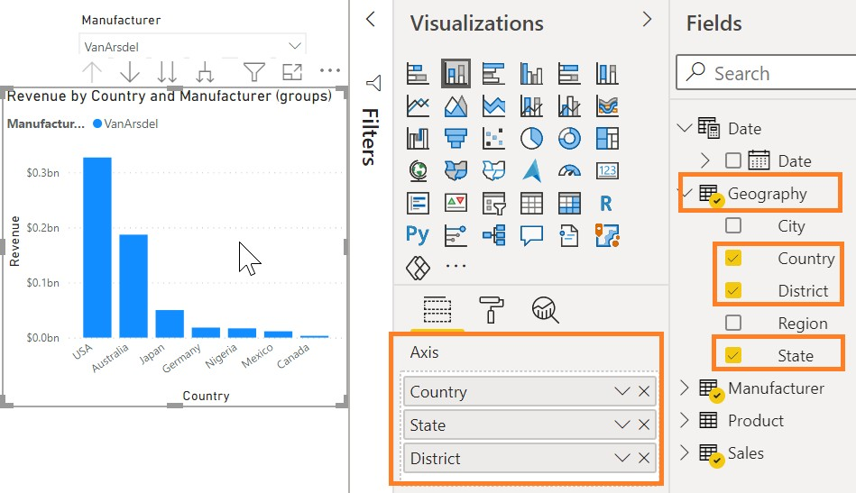

1. Make sure that **VanArsdel** is selected in the **Manufacturer** slicer.
2. Enable **Drill mode** by clicking the down arrow of the **Revenue by Country** visual.

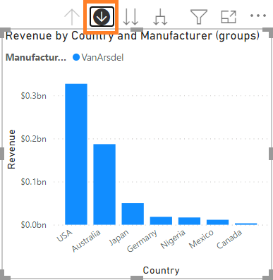

1. Click **Australia** to drill down to the **State** level.
2. From the **Revenue by Year** visual click **2020** and notice what happens to the **Revenue by Country**

and the **State** visual.

1. Now, **Drill up** to the **country** level.
2. Disable drill mode by clicking the down arrow again.

Now let’s analyze the data by product. We’ll start by creating a product hierarchy.

1. From the **Fields** section, click on the **ellipse** next to the **Category** field in the **Product** table.
2. Click **Create Hierarchy**.

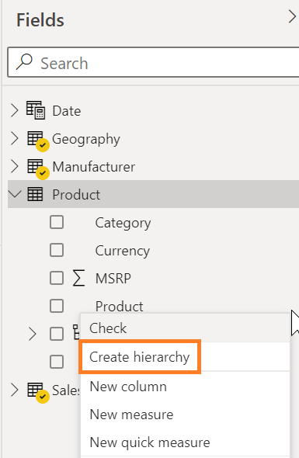

Notice that a new field called **Category Hierarchy** is created in the **Product** table.

1. Double-click **Category Hierarchy** and rename it to **Product Hierarchy**.

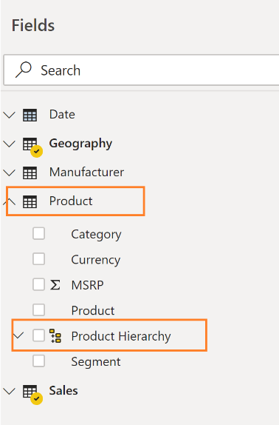

1. Click the **ellipse** next to **Segment**.
2. Click **Add to Hierarchy**, and then click **Product Hierarchy**.

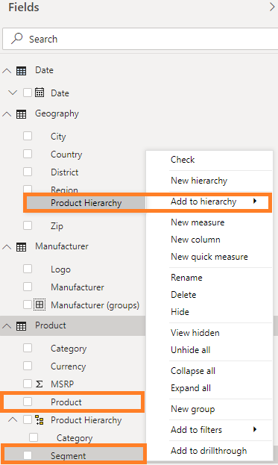

1. Click the **ellipse** next to **Product**.
2. Click **Add to Hierarchy**, and then click **Product Hierarchy**.

We have now created a Product Hierarchy with the priority of Category, Segment, and then Product.

1. Click on the white space in the canvas. From the **Visualizations** section, click **Clustered bar chart**.
2. From the **Fields** section, expand the **Product** table.
3. Click the checkbox next to the **Product Hierarchy**. Notice the complete hierarchy is selected.
4. From the **Fields** section, expand the **Sales** table.
5. Click the checkbox next to the **Revenue** field.
6. Ensure **Australia** and **2020** are selected.
7. Let’s edit interactions for the new chart.
8. Click the Format tab and click edit interations
9. Click on the **Revenue by Country** visual and change the **Revenue by Category** visual to **filter**

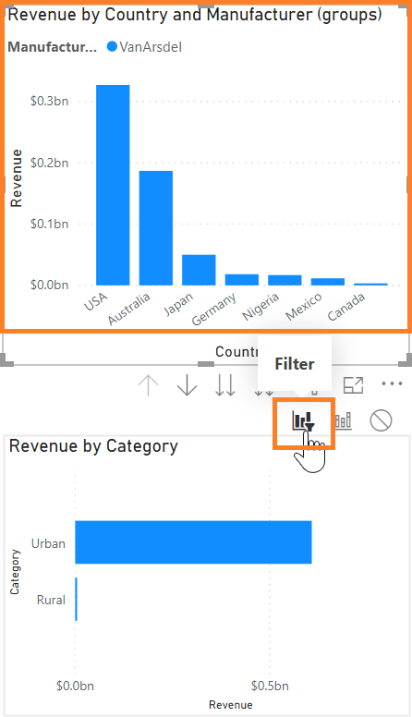

1. Do the same thing with the **Revenue by Year** visual, change the interaction of the **Revenue by Category** to **filter**
2. We also need to change the interactions of the other charts. Click on the Revenue by **Category**

visual and change the **Revenue by Yea**r visual to a **filter** action.

1. Click the **filter** interaction on the **Revenue by Country** visual as well
2. Click the **format** tab and click **Edit interactions** to turn it off
3. Let’s get back to the **Revenue by Category** visual

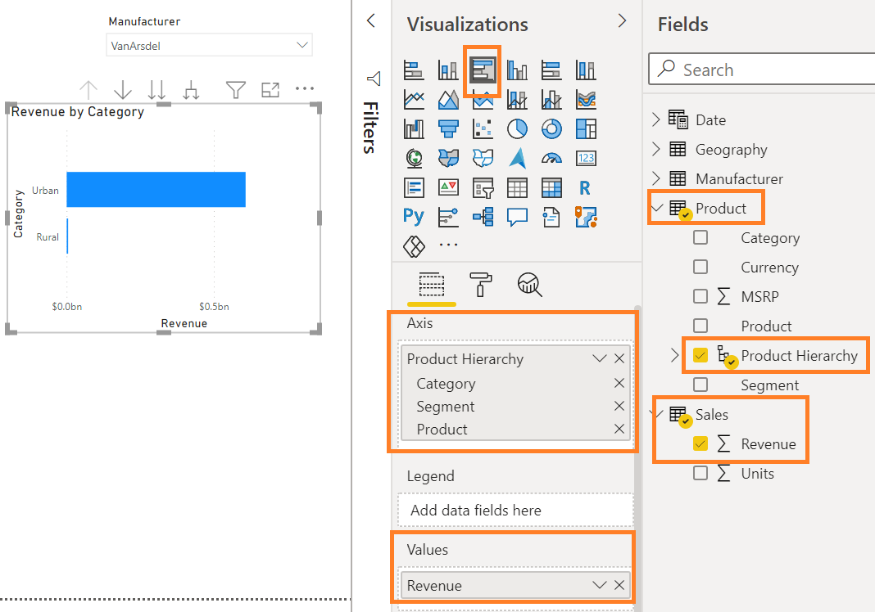

1. Enable drill-down mode in the **Revenue by Category** chart by clicking on the down arrow.

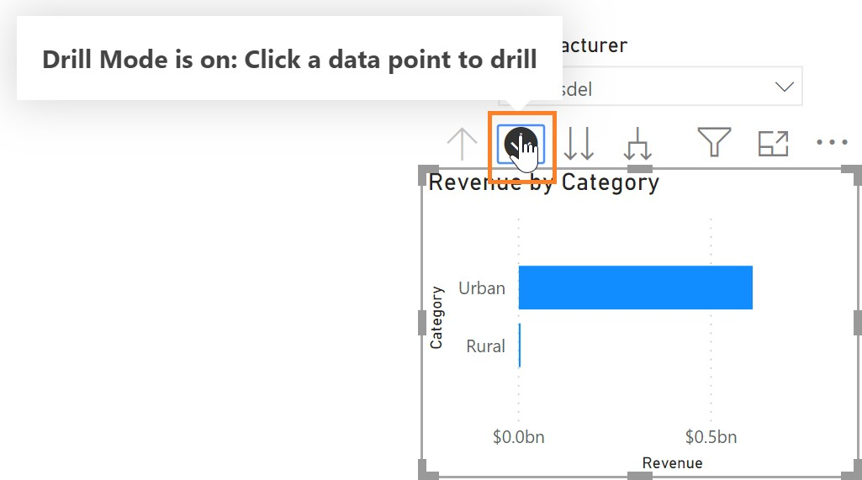

1. Click on **Urban.**
2. In the **Revenue by Country** visual, drill up to Country level **Australia** and disable drill down

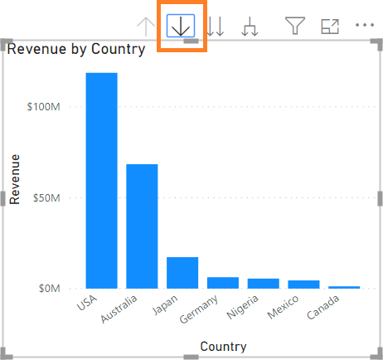

1. Click **Australia** in the **Revenue by Country** visual
2. **Ctrl+Click 2020** from the Revenue by Year visual. Notice that the sales in the **Extreme** category are higher than the **Convenience** and **Moderation** segments.

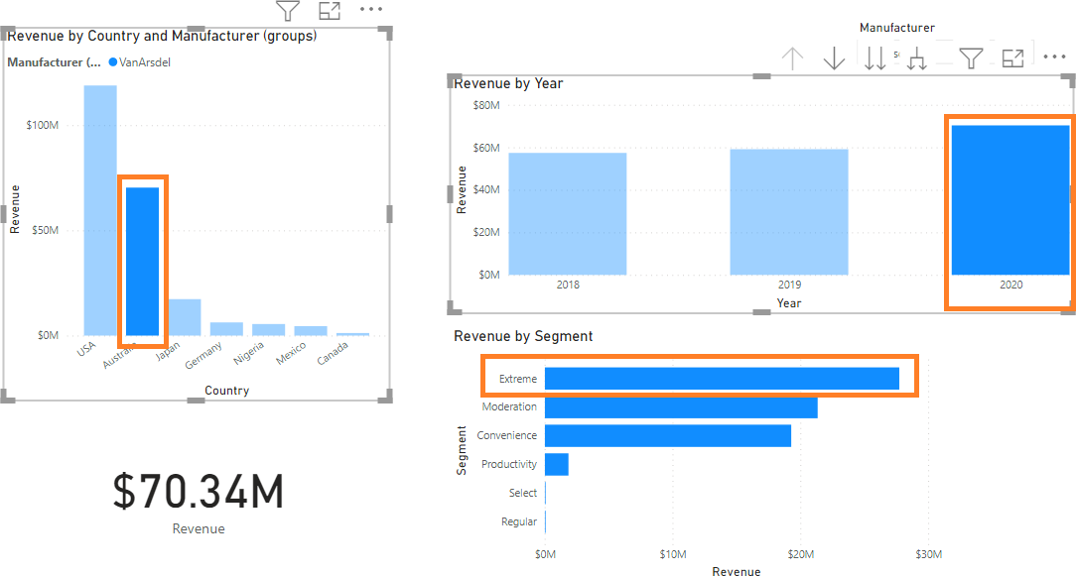

Let’s investigate further…

1. Click the down arrow at the top of **Revenue by Country** visual to enable the drill model.
2. Click **Australia** to drill down to the **State** level.

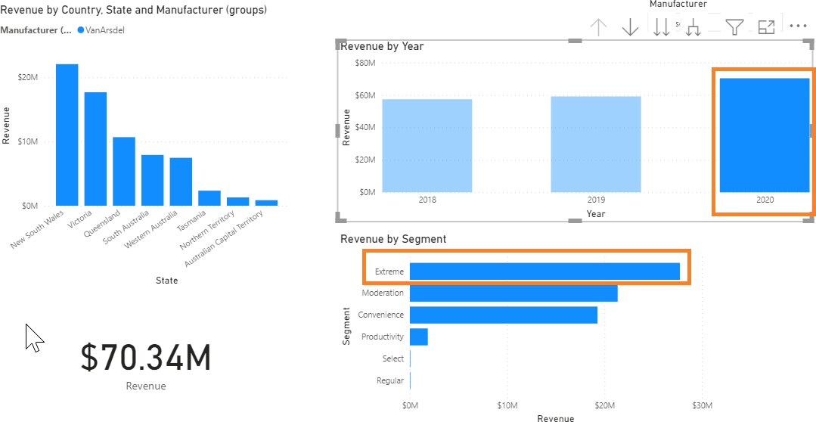

1. Click **2020** in the Revenue by Year visual.
2. **Ctrl+Click** the **Extreme** Segment in the Revenue by Category and Segment visual. Notice that there is no significant spike by State.
3. Click **Extreme** again to remove cross-filtering between the visuals.
4. **Drill up** to the **Category level** in the Revenue by Category visual.
5. Disable drill mode by clicking the down arrow again.
6. **Drill up** to **Country** in the Revenue by Country and State visual
7. Disable drill mode in the Revenue by Country visual

Now let’s add a Matrix visual so we can view the data in rows and columns. We can apply conditional formatting to the matrix visual to highlight the outliers.

1. Click on the **Revenue by Category** clustered bar chart and change it to a **Matrix** visual.

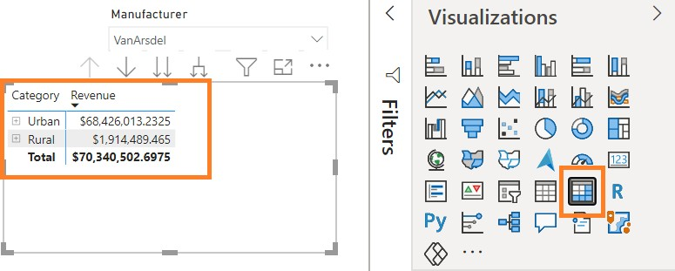

1. Click the **+** (plus sign) next to the **Urban** row to drill down.

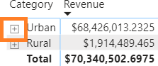

Let’s add a percent of the total field. This will give us a better perspective.

1. Navigate away from the **Format** section to the **Fields** pane.
2. From the **Fields** section, drag the **Revenue** field from the **Sales** table to below the existing

**Revenue** field in the **Values** section. It will look like you have Revenue twice in the fields pane

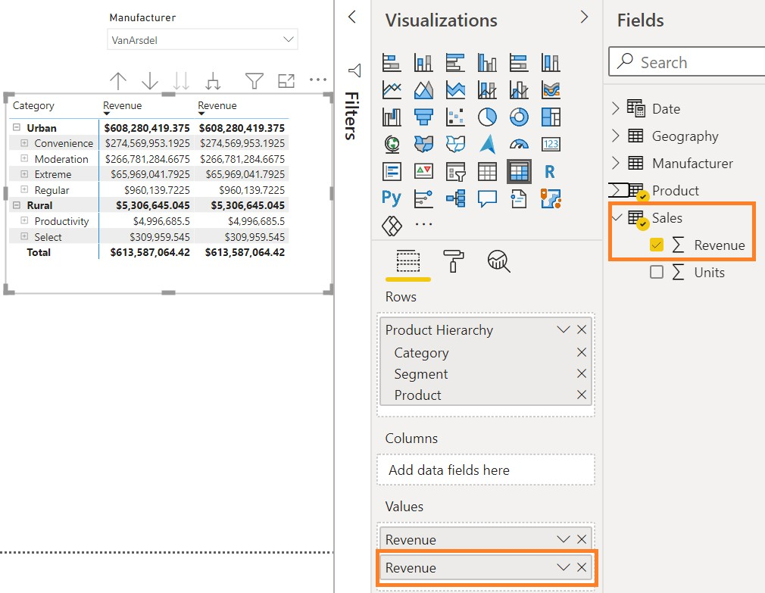

1. Click the **arrow** next to the newly added **Revenue** field.
2. From the menu, hover over **Show value as** and then click **Percent of grand total**.
3. Drill up to **Category** levelEnable drill mode on the **Revenue by Category** visual
4. Now click on **Urban** (the word, not the + sign)

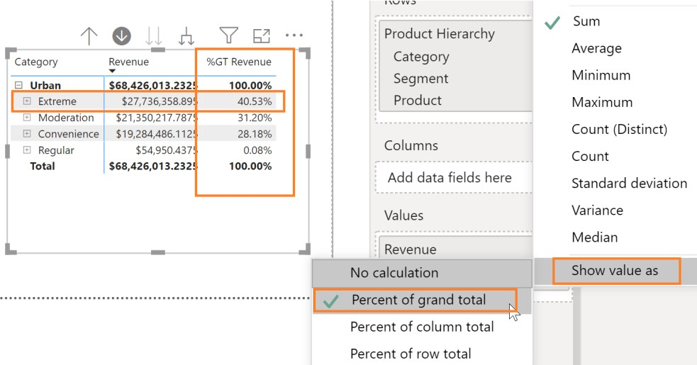

1. Make sure you have **Australia** and **2020** selected on the other charts. Now let’s look at the **Extreme** category for Australia over time.

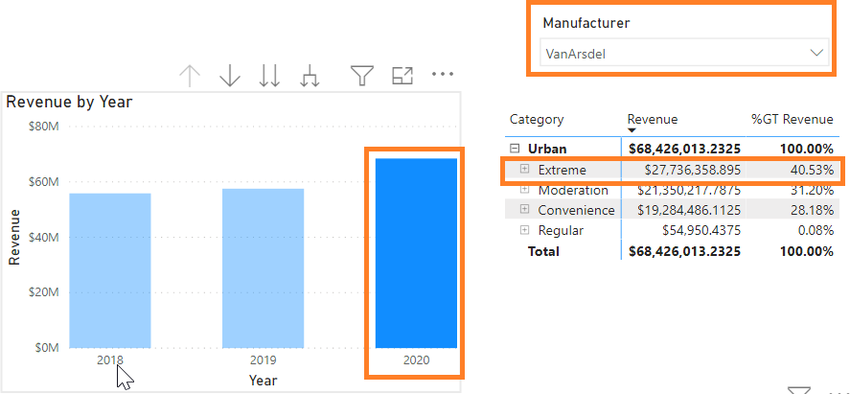

1. In the **Revenue by Year** visual click the **2020** column and click **Australia** in the **Revenue by Country** visual. Notice that the **Extreme** segment has around 40% of the grand total.
2. In the **Revenue by Year** visual click the **2020** column to remove the filter.

Now let’s drill down into the **Extreme Segment** and figure out if a Product stands out.

1. In the **matrix** visual, click the **Extreme** row to drill down to the Product level.
2. Resize the visual as needed.
3. Hover over the matrix visual and then click the ellipse in the top right corner.
4. Click **Sort By %GT Revenue** and then click **Sort Descending**.

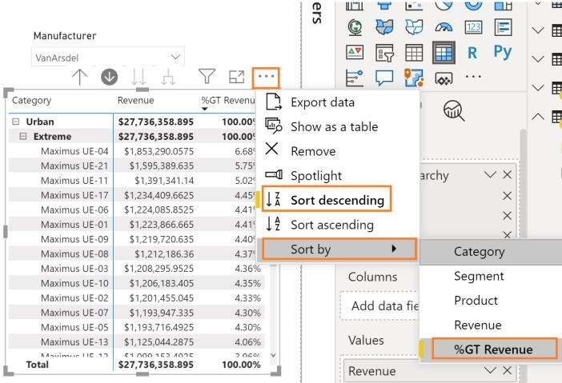

We can now see the top Products.

1. Ensure **2020** is selected in the **Revenue by Year** visual, and **Australia** in the **Revenue by Country** visual.. Notice that Maximus UE-04 and 21 are the top products. Also, notice that Product 04 has nearly 7% of the grand total and has a big spike.

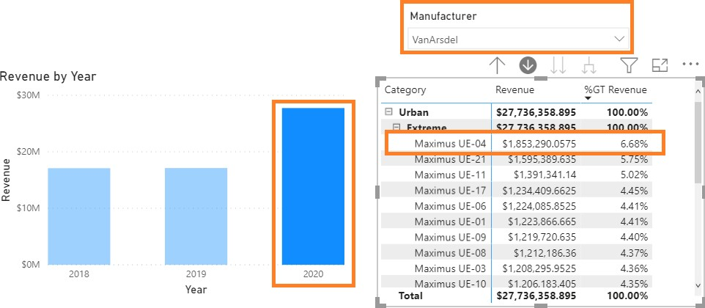

1. In the **Revenue by Year** visual, click the **2019** column to remove the filter.

Earlier we created a calculated column named **ZipCountry**. Now let’s create a **Percent Growth**

measure so we can compare sales over time. We are going to do this in two steps.

But first, what’s the difference between a measure and a calculated column?

* + A **Calculated column** is evaluated row by row. We extend a table by adding calculated columns.
  + A **Measure** is used when we want to aggregate values from many rows in a table.

1. In the **Fields** section, click the **Sales** table.
2. From the ribbon, click **Table Tools,** then click **New Measure**. A formula bar opens.

#### Enter PY Sales = CALCULATE(SUM(Sales[Revenue]), SAMEPERIODLASTYEAR('Date'[Date]))

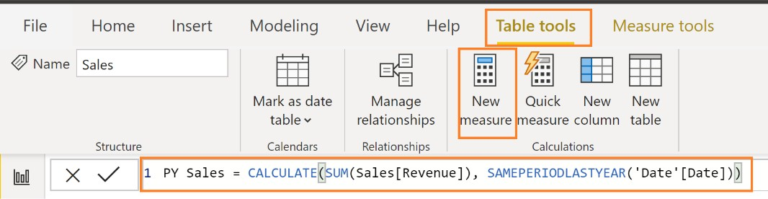

1. Click the checkmark next to the formula bar. You will see the **PY Sales** measure in the **Sales** table.

Let’s create another measure.

1. In the **Fields** section, hover over the **Sales** table.
2. Click on the **ellipse** in the right corner.
3. Click **New Measure** from the dialog box. A formula bar opens.

#### Enter % Growth = DIVIDE(SUM(Sales[Revenue])-[PY Sales],[PY Sales])

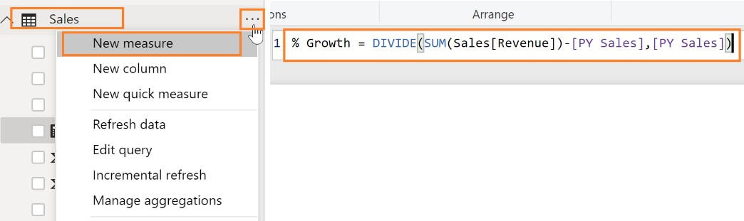

1. Click the checkmark next to the formula bar. You will see **% Growth** measure in the **Sales** table.
2. Click the **matrix** visual.
3. In the **Fields** section, click the checkbox next to the newly created **PY Sales and % Growth**

measures in the **Sales** table.

Notice that the Fields need to be formatted.

1. From the **Fields** section, click the **% Growth** field.
2. From the ribbon, click **Measure Tools**, click **Format**, and then click **Percentage.**

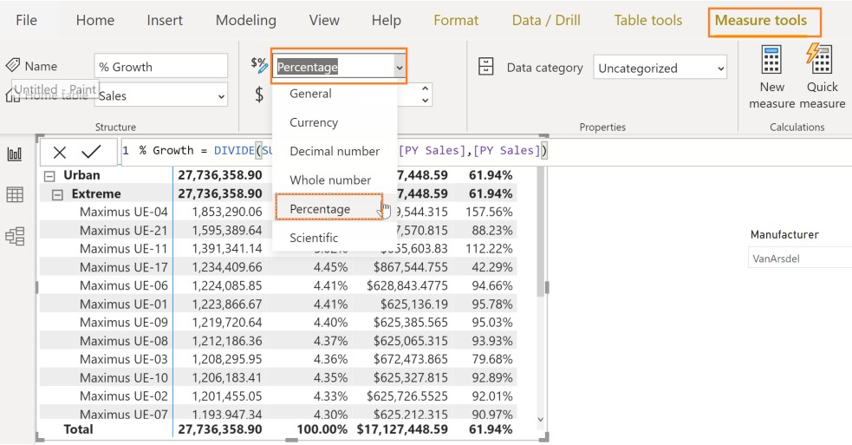

1. Similarly, from the **Fields** section, and then click the **PY Sales** field.
2. From the ribbon, click **Measure Tools**, click **Format**, and then click **Currency,** if it isn’t already

formatted Currency **.**

1. Similarly, from the **Fields** section, and then click the **Revenue** field.
2. From the ribbon, click **Measure Tools**, click **Format**, and then click **Currency** if it isn’t already

formatted to Currency

1. Ensure that **Australia** is selected and In the **Revenue by Year** visual, Ctrl + click the **2020** column. Notice that Maximus UE-04 has nearly 158% growth compared to last year.

